5. Implement K-Means Clustering

Aim:
To implement the K-Means clustering algorithm using Python to group similar data points into clusters.
Algorithm:
- Start the program.
- Import the required libraries, NumPy and Scikit-learn.
- Create a dataset containing input data points.
- Initialize the K-Means clustering model with the required number of clusters.
- Fit the model to the dataset.
- Assign each data point to its nearest cluster.
- Display the cluster labels and cluster centers.
- Stop the program.

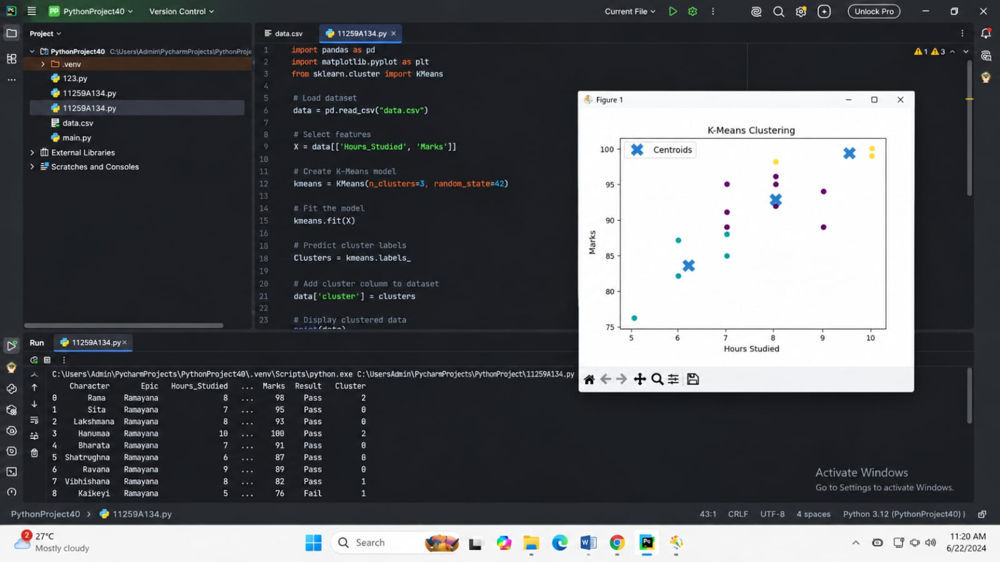
CODE AND OUTPUT:

Result:
Thus, the K-Means clustering algorithm was successfully implemented using Python, and the data points were grouped into clusters based on their similarities.

